**PAYROLL MANAGEMENT SYSTEM**

**Aim:** The main objective of this system is to get the salary details of each employee in the company.

**Features**: Using this system we can know the details of each employee, his/her salary details, salary break up and the different Basic pay based on his/her experience. The salary break up includes Basic salary, HRA, Conveyances, Medical allowances or any special allowances, PF. The payment deductions based on any tax or number of leaves can be calculated.

**Entities:**

1. Employee
2. Department
3. Basic salary
4. Salary
5. Tax
6. Leaves
7. Deductions
8. Payment

**Attributes:**

1. Employee

* emp_id
* emp_name
* emp_phone
* emp_email
* emp_exp

1. Department

* dept_id
* dept_name
* emp_id

1. Basic salary

* exp
* bs_pay
* pf

1. Salary

* Emp_id
* Emp_name
* bs_pay
* allowances
* conveyance
* pf
* gross_salary

1. Tax

* Emp_id
* Tax_amt

1. Leaves

* Emp_id
* Leaves_no
* Leave_amt

1. Deductions

* Emp_id
* Tax_amt
* Leave_amt
* Deduct_amt

1. Payment

* Emp_id
* Emp_name
* Gross _sal
* Deduct_amt
* Tot_salary

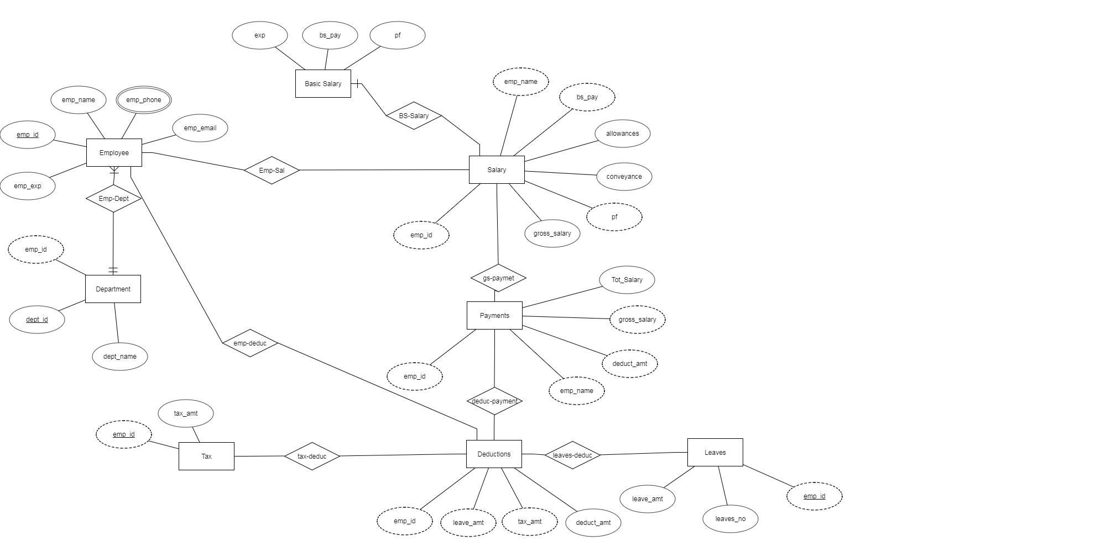

ER Diagram